Simulation & Digital Twins / Humanoid Simulation / github.com/Bakel-Bakel/naoCoppeliaSim
NAO Humanoid in CoppeliaSim
PROJECT DESCRIPTION
This project drives a virtual NAO humanoid inside CoppeliaSim from external Python code, using the ZMQ Remote API as the bridge between the simulation and a clean, scripted controller. The setup is deliberately minimal on the simulator side: enable the ZMQ server, point the Python client at port 23000, and the rest of the work happens in regular Python with no need to write Lua scripts inside the scene itself. That keeps the experiments easy to version control, easy to share, and easy to plug into wider toolchains. The repository ships with a set of basic command scripts that exercise the standard NAO repertoire: walking, waving, speaking, and tracking objects through the on board cameras, plus a separate nao_rl module that opens the door to reinforcement learning experiments where the same scene can be wrapped as a training environment. A setup.sh handles the dependency install in one go, and the steps.txt walks through getting the ZMQ Remote API talking to the script, so the project is genuinely usable as a starting point for robotics research, AI experiments, and classroom demos.
TECHNOLOGIES & SKILLS
Python | CoppeliaSim | ZMQ Remote API | NAO Humanoid
Reinforcement Learning | Object Tracking | Bipedal Walking | Inverse Kinematics
Simulation | Robotics Research | Shell Scripting | Digital Twin
TECHNICAL HIGHLIGHTS
- Python controller that drives the NAO humanoid inside CoppeliaSim through the ZMQ Remote API, with no Lua scripts on the simulator side.
- Basic command scripts covering the staple NAO repertoire: walking, waving, speaking, and visual tracking of objects through the on board cameras.
- Separate nao_rl module that wraps the simulator as a reinforcement learning environment, ready to be plugged into agents and training loops.
- Default port 23000 for the ZMQ Remote API, kept consistent with the CoppeliaSim default so the bridge works without configuration tweaks.
- setup.sh that installs the Python dependencies in one shot, and a steps.txt that walks through enabling the API on the simulator side.
- Designed as a starting point for robotics research, AI experimentation, and classroom demos, where the goal is to script behaviour rather than fight the simulator.
PICTURES
BLOCK DIAGRAM
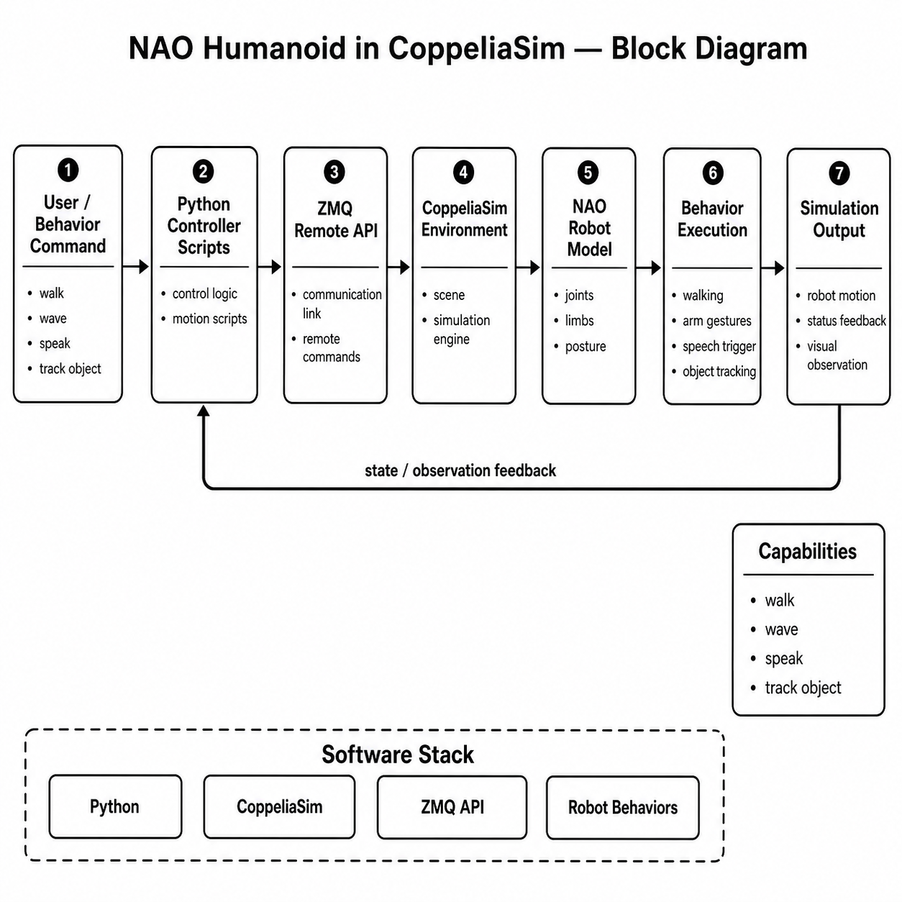
FLOWCHART
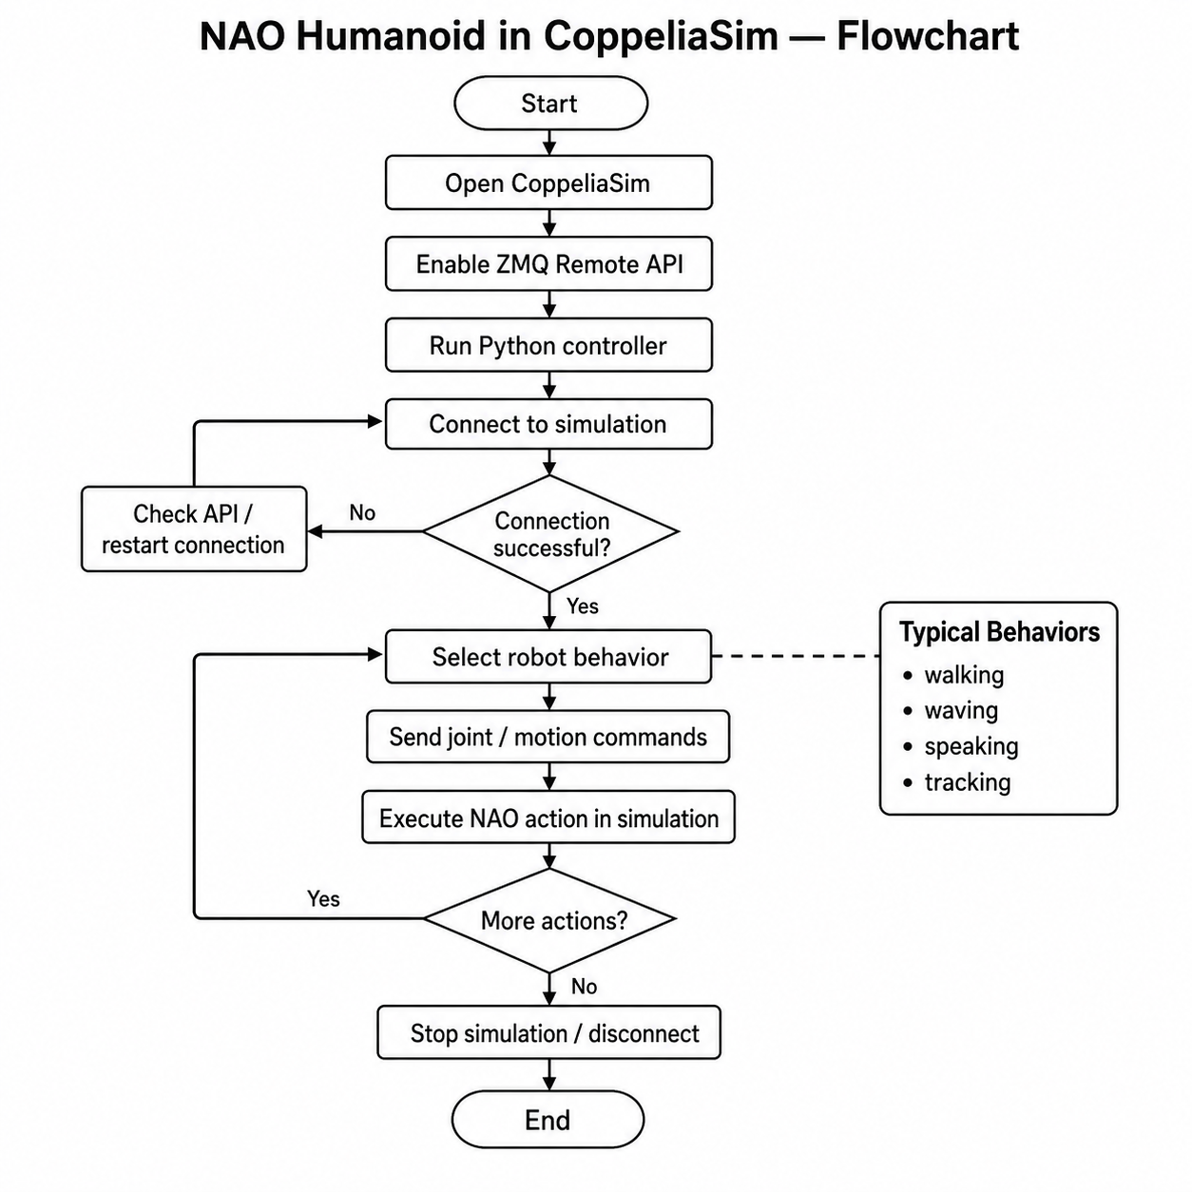

SEQUENCE DIAGRAM
